**CustomItNow**

**Technical Specification Document**

C:\Users\vishal\Desktop\New folder\Docs\CIN DFD.pngData Flow Diagram

We will be handling the following sets of data.

1. Seller data
2. User data
3. Execution data
4. Admin data

* **Seller Data**
  + Fabric Sellers and Product details
  + Tailor information
* **User Data**

We should be able to obtain the below mentioned information from every website visitor.

* + - * Visitor monitoring including pages they visit, location, IP, where does one close the website etc. – using Google Analytics
      * Register with email/phone & OTP (or) Social media login (Pop up every 15 -30 secs for non-registered visitors)
      * Wish list, Order & Tracking (for ongoing orders)
      * Addresses, Measurements & preferences (post measurement visit)
      * Feedback (during any point of time)
      * Email enquiries
* **Execution Data**

Data that will be got from execution team via the business app.

* + - * Fabrics availability and shipment & Tailor availability confirmation
      * Measurement visit (via business app)
        + Measurement, Trial visits date & time confirmation
        + Customer measurement
        + Design preferences
        + Other suggestions
      * Trial visit (via business app)
        + Order confirmation
        + Fitting feedback
        + Suggestion & preferences
        + Expected Delivery Date
      * Delivery (via business app)
        + Delivery confirmation
        + Other feedbacks
* **Admin Panel**

Admin should display the following data in the dash board. All the metrics mentioned below should be stored with excel sheet downloadable options for analysis.

* No of registered users (overall, weekly, monthly)
* No of Sellers and their sales. Active & Inactive sellers
* No of visitors (overall, current traffic, geographic location, traffic reports weekly & monthly)
* No of order (overall, ongoing, completed, daily, weekly, monthly + tracking individual orders + executives assigned)
* Sale (Overall amount, weekly, monthly, yearly tracking report)
* No of executives (Total no, on field numbers, no of execs who are free)
* Website movement of users (Pagewise traffic, which page are they closing the tab, button clicks, active time in each page, other important analytics reports weekly & monthly)
* Social media analytics (fans, engagements, trending metrics of brand)
* Sync to [ask@customitnow.com](mailto:ask@customitnow.com) & [orders@customitnow.com](mailto:orders@customitnow.com)

Admin is main connecting platform for user & execution data. Admin will have the following data.

* + - * Fabric Data (updatable for Seller & Products to be added, removed. To be in real time sync with website)
        + Seller Name
        + Products with images, description and prices
      * Tailor Data (excel sheet updatable for tailors to be added, removed. To be in real time sync with website)
        + Tailor name, Map location, address, mobile, landline, email, established year, team size
        + Shop images
        + Tailor registration no, bank details, PAN/TAN/SNO, legal documents (for internal use)
        + Specialization
        + Rate cards
        + Delivery Time / Express Delivery available?
        + Tailors open to go for delivery (internal use)
      * Execution Team Data (excel sheet updatable for members to be added, removed)
        + Ground execution team with availability and completed orders & ongoing order status
        + Live sync of data fed in through business app
      * Admin should also have records of visitors, IP, geographical location and other analytics

**Other processes:**

* Everything related to users, fabric sellers & products, tailors, orders and execution team data should be managed and updatable via the Admin console through excel sheets. To be shown on real time on the website
* Design should be very simplistic and easy to understand for anybody. Simple words, simpler design, simplistic yet clear and best user experience
* Once a fresh visitor enters a register/login pop up should prompt at 45 secs
* Registration options – Mail id, mobile no & password with a confirmation mail/sms + Social media login
* New registered users should get a welcome mail and SMS
* For registered used, it should remember them and auto login them
* Visitor browsing history, recently viewed products/tailors should be monitored to showcase products of their interest
* Payment options: Credit/Debit card, Net Banking, PayTM and Mobikwik wallets, Cash on delivery
* Every order update has to be mailed and SMS to the user, the same must be updated on user profile
* Reminder to execution team 1 day prior to visit date, emails.
* Suggestions from execution team and Customer side should be updated in the Admin panel
* After delivery, feedback mailer on delivery service, tailor review and other suggestions to be got from user through mailer & through registered user profile
* Design to be very simplistic. 3 clicks order for users. Anywhere we ask or talk some new terms, there should be icon put to explain user what is it.
* When we collect the mobile no from user, we need to send auto OTP to confirm mobile
* Tags of all forms to be included in the website to enable online visibility

**Website – User flow:**

* Users to choose from Men/Women and specific apparel to be stitched
* Choice of fabrics for the particular apparel to be shown with filter options (price, Quality, etc.)
* Fabric checkout options – Only **Buy Fabric** (Direct payment and delivery) or **Stitch Fabric**
* Clicking on ‘Stitch fabric’ to show list of tailors who could stitch that particular apparel
* Users can also skip fabric and just choose tailors by using filter option on the list page
* Clicking on any tailor, opens the individual tailor page showing details like Name, Area, Specialization, Delivery types available (Regular 8-10 days, Express 2-4 days) , Charges, Reviews etc.
* Users can book appointment on the individual tailor page. (*users should be logged in after this session)
* To confirm appointment, users need to input date, time, address, measurement option(online, sample pick up, tailor visit), upload reference images for style choice and proceed
* Payments can be done instantly or on delivery and Order id will be generated
* Post Order: Users will be notified by SMS and Calls for the visits and every visit feedback from Measurement, style preferred, ref image, address, order status etc. to be saved in the user profile

**Order – Flow:**

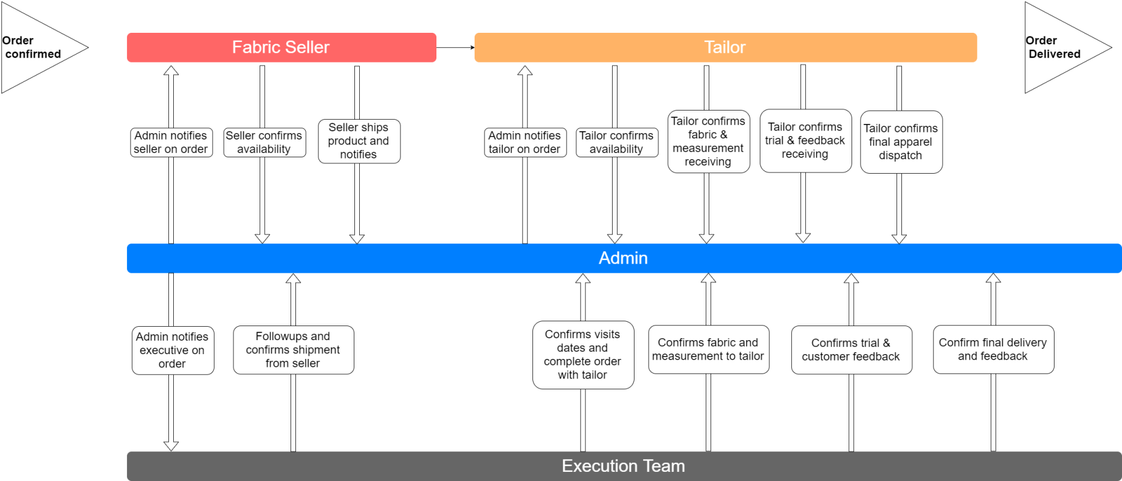

**Fabric Seller:**

* Once order is received, Seller to be notified via SMS and email + call from delivery executive
* Post confirmation of availability of the fabric, the delivery team will pick up or the seller will ship the product to be handed over to the user (if only shopping for fabric) / tailor (for stitching)
* Pick up / Fabric shipment must be notified to delivery team

**Tailor:**

* Once order is received, Tailor will be notified via SMS and email + call from delivery executive and confirmation to be taken. Fabric update also to be taken
* Measurement Visit - User measurements and suggestions to be shared by the execution team to the Tailor and confirmation to be taken. Trial dates to be confirmed by both parties
* Trial Visit – Execution team to share the trial feedback and other suggestions. Delivery dates to be confirmed by both parties
* Delivery – Execution team to pick up apparel from Tailor and deliver to user. Feedback and suggestions of user to be updated

**Execution:**

* Once an order is received, an on-ground executive will be assigned to fulfill the order from start to delivery
* Ground team executives to use the business app to update all necessary information to the Admin
* Executives to co-ordinate with tailor and customer and update all necessary information from Tailor confirmation, Visit updates and Delivery to customer appointment confirmation, visit updates, delivery and other suggestions\

**Business App:**

App to be able to function as mentioned below.

**Phase 1: For onboarding and business use**

* To be able to take Fabric and Tailor data mentioned below
* Fabric Data (updatable for Seller & Products to be added, removed. To be in real time sync with website)
  + - * + Seller Name, Address, Bank details
        + Products with images, description and prices
* Tailor Data (excel sheet updatable for tailors to be added, removed. To be in real time sync with website)
  + - * + Tailor name, Map location, address, mobile, landline, email, established year, team size
        + Shop images
        + Tailor registration no, bank details, PAN/TAN/SNO, legal documents (for internal use)
        + Specialization
        + Rate cards
        + Delivery Time / Express Delivery available?
        + Tailors open to go for delivery
        + Fabric options? (do they stitch only their fabric or customers fabrics)
* Execution Team Data (excel sheet updatable for members to be added, removed)
  + - * + Ground execution team with availability and completed orders & ongoing order status
        + Updates of all visits and suggestions from Fabric Seller, Tailor and Customers
        + Live sync of data fed in through business app

**Phase 2: For sellers and business use**

* Fabric sellers, Tailors and CustomItNow on-ground executive team to use the app
* Sellers & Tailors to use app to monitor previous, on-going orders with option to update status reports and monitor their sales
* CustomItNow on-ground executive team to use the app for on-boarding and order fulfillment updates